**Assignment – 3**

|  |  |
| --- | --- |
| Assignment Date | 31 october 2022 |
| Team ID | PNT2022TMID50324 |
| Project Name | Nutrition Assistant Application |
| Maximum Marks | 2 Marks |
| Batch no. | B2-2M4E |

# Question 1 :

Create a Bucket in IBM Object Storage.

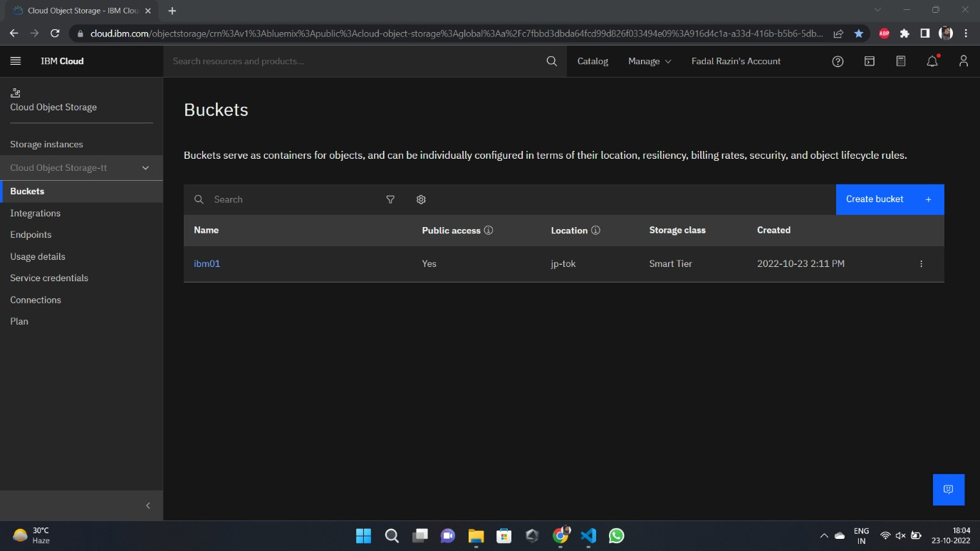

# Question 2 :

Upload an 5 images to IBM object storage and make it public. write html code to displaying all the 5 images.

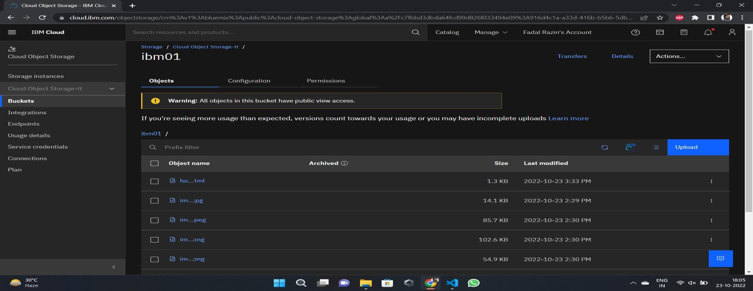

# Question 3 :

Upload a CSS page to the object storage and use the same page in your HTML code.

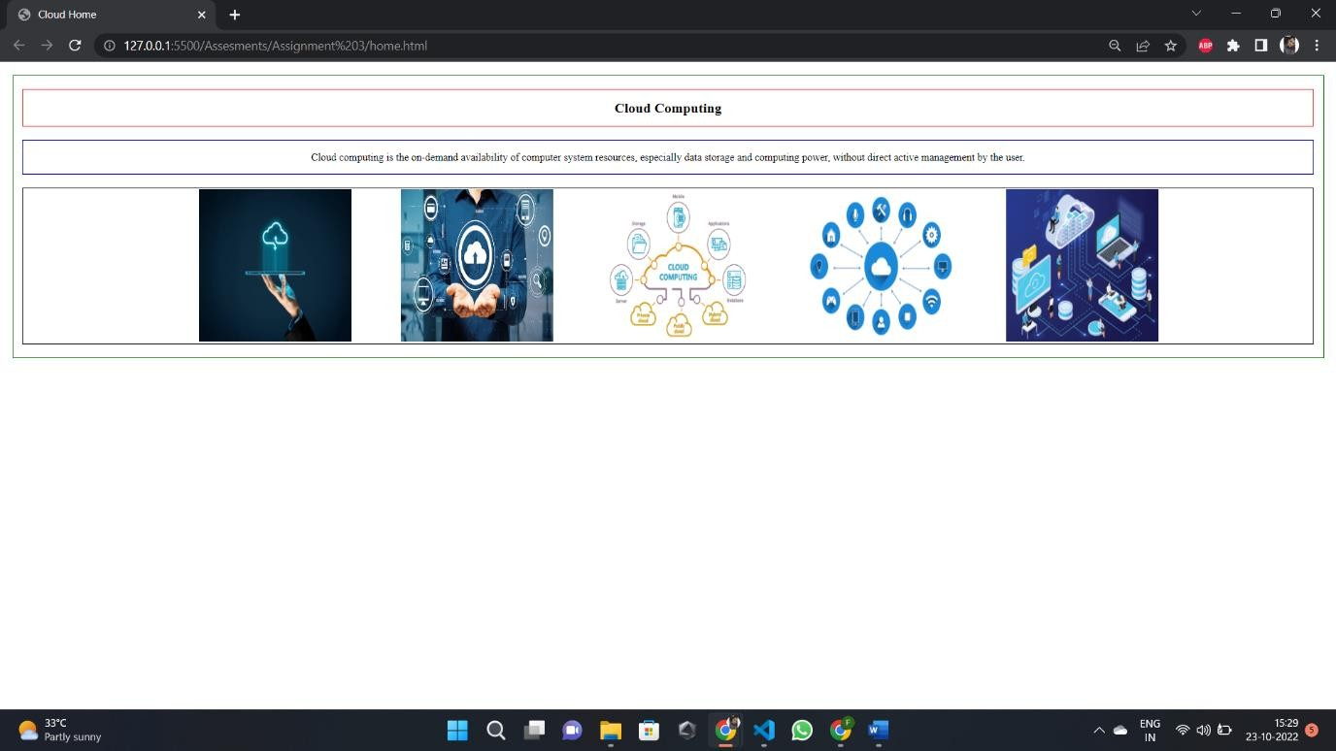

# Question 4 :

Design a chatbot using IBM Watson assistant for hospital. Ex: User comes with query to know the branches for that hospital in your city. Submit the web URL of that chat bot as a assignment.

**[https://web-chat.global.assistant.watson.appdomain.cloud/preview.html?backgroundImageURL=https%3A%2F%2Fau-](https://web-chat.global.assistant.watson.appdomain.cloud/preview.html?backgroundImageURL=https%3A%2F%2Fau-syd.assistant.watson.cloud.ibm.com%2Fpublic%2Fimages%2Fupx-3c53ca7b-ce74-4ac8-b25c-8f69b083274a%3A%3A443fb1bd-945b-4727-b6f4-1929720ae6ff&integrationID=3d5eea10-931a-4d86-9986-77ae1738437a&region=au-syd&serviceInstanceID=3c53ca7b-ce74-4ac8-b25c-8f69b083274a) [syd.assistant.watson.cloud.ibm.com%2Fpublic%2Fimages%2Fupx-3c53ca7b-ce74-4ac8-b25c-](https://web-chat.global.assistant.watson.appdomain.cloud/preview.html?backgroundImageURL=https%3A%2F%2Fau-syd.assistant.watson.cloud.ibm.com%2Fpublic%2Fimages%2Fupx-3c53ca7b-ce74-4ac8-b25c-8f69b083274a%3A%3A443fb1bd-945b-4727-b6f4-1929720ae6ff&integrationID=3d5eea10-931a-4d86-9986-77ae1738437a&region=au-syd&serviceInstanceID=3c53ca7b-ce74-4ac8-b25c-8f69b083274a) [8f69b083274a%3A%3A443fb1bd-945b-4727-b6f4-1929720ae6ff&integrationID=3d5eea10-931a-4d86-9986-](https://web-chat.global.assistant.watson.appdomain.cloud/preview.html?backgroundImageURL=https%3A%2F%2Fau-syd.assistant.watson.cloud.ibm.com%2Fpublic%2Fimages%2Fupx-3c53ca7b-ce74-4ac8-b25c-8f69b083274a%3A%3A443fb1bd-945b-4727-b6f4-1929720ae6ff&integrationID=3d5eea10-931a-4d86-9986-77ae1738437a&region=au-syd&serviceInstanceID=3c53ca7b-ce74-4ac8-b25c-8f69b083274a) [77ae1738437a&region=au-syd&serviceInstanceID=3c53ca7b-ce74-4ac8-b25c-8f69b083274a](https://web-chat.global.assistant.watson.appdomain.cloud/preview.html?backgroundImageURL=https%3A%2F%2Fau-syd.assistant.watson.cloud.ibm.com%2Fpublic%2Fimages%2Fupx-3c53ca7b-ce74-4ac8-b25c-8f69b083274a%3A%3A443fb1bd-945b-4727-b6f4-1929720ae6ff&integrationID=3d5eea10-931a-4d86-9986-77ae1738437a&region=au-syd&serviceInstanceID=3c53ca7b-ce74-4ac8-b25c-8f69b083274a)**

# Question 5 :

Create Watson assistant service with 10 steps and use 3 conditions in it. Load that script in HTML page.

